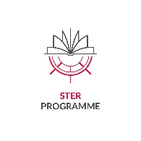

Appendix no. 9

STATEMENT OF READINESS

I, the undersigned, hereby declare my readiness to join and commence the work on the project: "Internationalization of PhD Schools at NCU: a platform for joint and double degree" [PhD @ NCU], implemented under the STER programme.

…..………………………… …………………………………………………………
Place and date Legible signature of the Applicant

