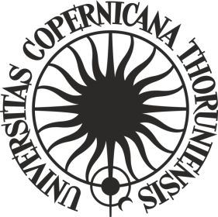
ORDER No. 156

of the Rector of the Nicolaus Copernicus University in Toruń
of 21 October 2019

amending Order No. 138
of the Rector of the Nicolaus Copernicus University of 1 October 2019
Rules for granting benefits to students of the Nicolaus Copernicus University in Toruń

Pursuant to art. 95 of the Act of 20 July 2018 - Law on Higher Education and Science (Dz. U. of 2018, item 1668 as amended) and art. 281 of the Act of 3 July 2018 the Provisions implementing the Act - Law on Higher Education and Science (Dz.U. of 2018, item 1669 as amended)

i t i s o r d e r e d as follows:

Article 1
Order No. 138 of the Rector of the Nicolaus Copernicus Office of 1 October 2019 - Rules for granting benefits to students of the Nicolaus Copernicus University in Toruń (Biuletyn Prawny UMK of 2019, item 326), shall be amended as follows:

- Article 19.2 footnote 4 shall be replaced by the following:
„⁴ International conference - points are awarded for active participation in a conference (excluding conferences conducted exclusively by means of electronic communication) in which at least 1/3 of active participants presenting papers represented foreign scientific centres.”;

- Article 19.2 footnote 5 shall be replaced by the following:
„⁵ National conference – points are awarded for active participation in a conference (excluding conferences conducted exclusively by means of electronic communication) which was attended by representatives of at least 5 scientific institutions”.

Article 2
The Order shall enter into force as of 21 October 2019 upon agreement with the Student Government.

R E C T O R

prof. dr hab. Andrzej Tretyn

