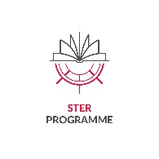
Appendix no. 7

Declaration of the Possibility of Scientific Internship Performance

Host University
(Please provide the name)

hereby declares the possibility to undergo and execute a 6-month Scientific Internship at the …… (Name of the Host University) …... located in ……(Address)…. The Internship will be conducted by the doctoral student ………… (name of the doctoral student) ………………………………… in the period from .......................to........................ under the supervision of………………..(name of the host/supervisor)…………. The financial costs of accommodation, maintenance and travel related to the participation of doctoral students in foreign research trip will be financed as a part of the PhD@NCU project implemented under the NAWA STER program by the Nicolaus Copernicus University in Toruń.

(Host University)

________________________
(NAME)
(TITLE)
Date:

